**Describe: The purchasing cycle daintily purchasing documents and their use to control food purchases (P1)**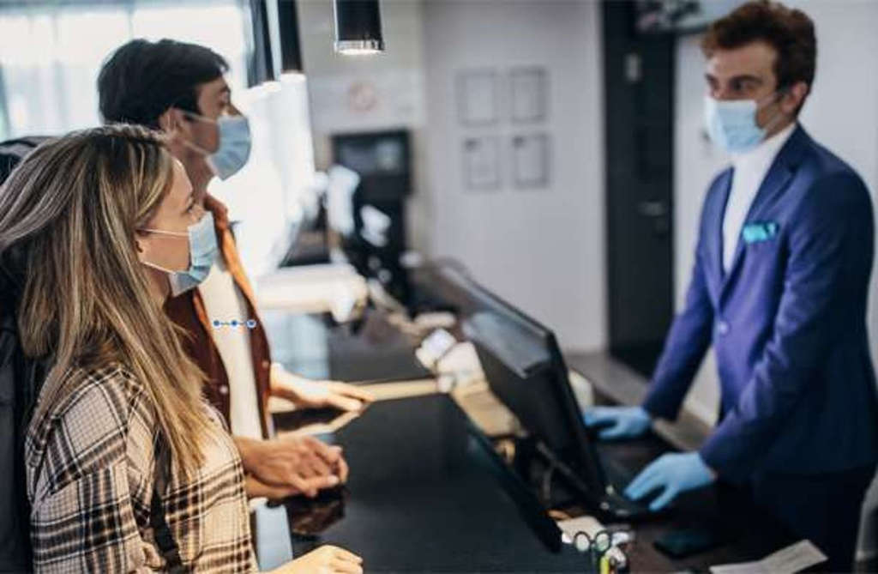

**The purchasing cycle**

* The selection of a vendor, the purchase of goods or services from them, and the continuous performance management of that vendor are all parts of the procurement cycle. In most circumstances, the procurement process is circular and is also referred to as the procurement life cycle, purchasing cycle, or sourcing cycle.

**What are the purchasing document used in the hospitality industry**

* details for visitors
* Supply chain details
* Employee records
* general communication
* Health, safety, and upkeep records

**How food purchasing can be controlled by the purchasing document**

* Set objectives and goals.
* Observe strict stock control.
* Managing your suppliers and maintaining a positive working relationship.
* Keep stock management and the purchasing department in sync.
* study sales data.

**Btec international level 2 hospitality**

**Unit 8 : Preparing cooking and presenting dishes**

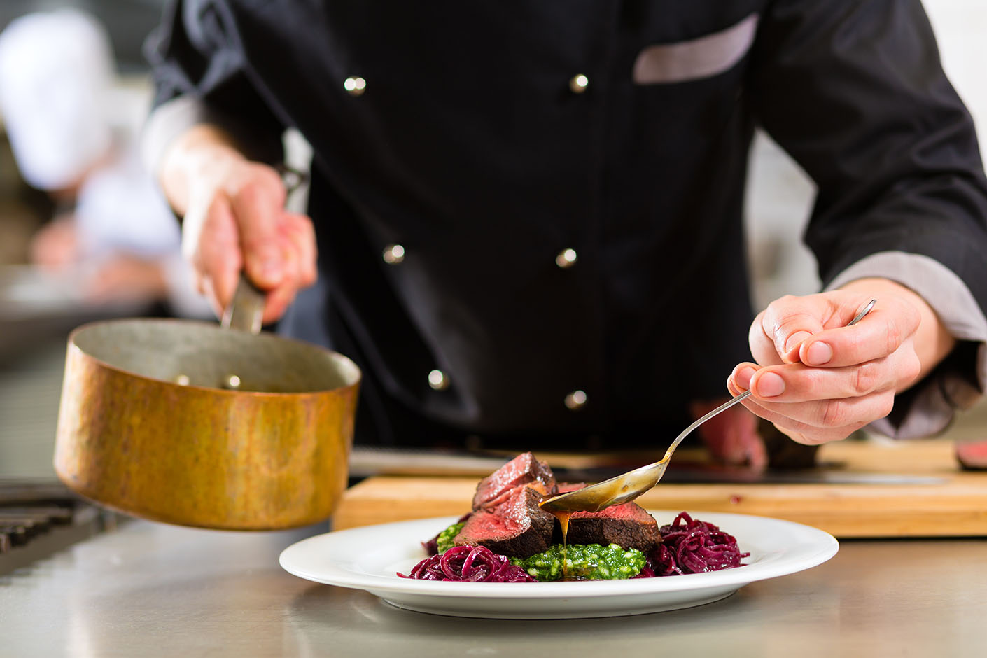

**SCHOOL: Thaajuddeen**

**CLASS: 10 btec**

**NAME: Hussain Maain**

**INDEX: 10603**